**Use NORTHWIND database to perform following queries:**

1.Get USA and UK Customer's List and their Contact Information. (Table: Customers)

2. Get Customer List who are from USA or from SP Region of Brazil. (Table: Customers)

3. Get all the CustomerID and OrderID for order placed in third quarter of 1997. (Table: Orders)



4. Get the Customer who's Company Name starts with either A, B, C, D, E, F, or G and ends with N or E. (Table: Customers)

5. Get the list of Customers where Company Name's 2nd letter is Consonant. (Table: Customers)

7. We acquire new Shipper and it does not ship to PO Box. Generate the list of Customers which has PO Box address. (Table: Customers)

8. Get the Customer Count by (Table: Customers)

            i. Country

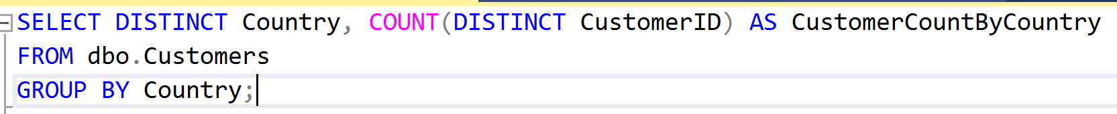

            ii. Country, Region

            iii. Country, Region, City

9. The Company wants to increase its relationship with higher raking officers of Customer. Get the Count of Contact's person by their title. (Table: Customers)

10. Get the list of Customers and Number of Orders placed by each customer till date. (Table: Orders)

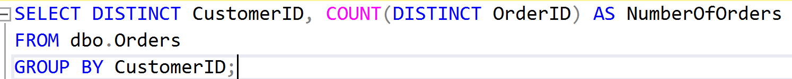

11. Get the top 10 Customers who has placed most order till date. (Table: Orders)

12. Get Customers list who has placed 5 or more Orders. (Table:Orders)

13. Get the Order Count by (Table:Orders)

            I. Each Year (Hint: YEAR() function)

          ii. Each quarter in each year (Hint: research on DATEPART() function)

iii. Each Month in each year (Hint: research on DATEPART() function)

14. Calculate Average, Total, Minimum, and Maximum Frieght paid (Table:Orders)

            i. For each Order

            ii. For each Company

            iii. For each Country on all orders

            iiv. for Each Carrier (ShipVia)

15. List Total Sale for each Product in each Order (Hint: UnitPrice * Quantity - UnitPrice * Quantity * Discount)

16. For each Order Calculate (Table: [Orders Details])

            i. Types of Products Ordered (Hint: Count on Product)

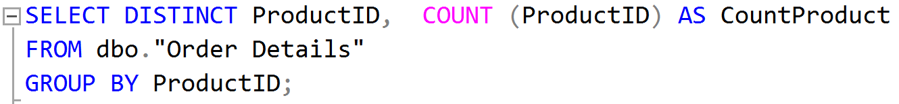

            ii. Total Sale for each Order

17. List total Quantity Ordered for Each Product on all orders. (Table: [Orders Details])

18. List top 10 Most Sold products in quantity in an order. (Table: [Orders Details])

19. Provide a SQL statement and sample result set that will count orders for all Customers within the SP (Brazil) state during the 1997 calendar year sorted by Customer name.

20. Provide a SQL statement and sample result set that will list all Customers within the SP (Brazil) state that have placed 7 or more orders during the 1998 calendar year.